

**CS 306, Database Systems**

**Project Phase 4**

Can Çiftçioğlu, 26532

Eda Nur Demir, 28916

**Submission Date:** 05.01.2024

We created an admin panel in which data can be inserted to several of our tables. We can delete users by using their id from this page. The page has users table at the end of it. Therefore, the admin can easily see the most important table without leaving the admin panel. We also added a background.

We added a homepage akin to LinkedIn's feed that highlights posts and connections people have made because we are developing a database application for LinkedIn. The page connects several databases. For example, when printing the posts, the "post" database's "post" content (text) and poster's id are used. It determines whether that ID belongs to a company or a user. In the event that it is a user, it prints the user's name along with the ID and links this ID number to the users page. If it's a company, it operates similarly using the database of the company. Additionally, it reads two inputs from the connections database, user1 and user2, locates those IDs in users or companies, and outputs a message indicating that the connection was made.

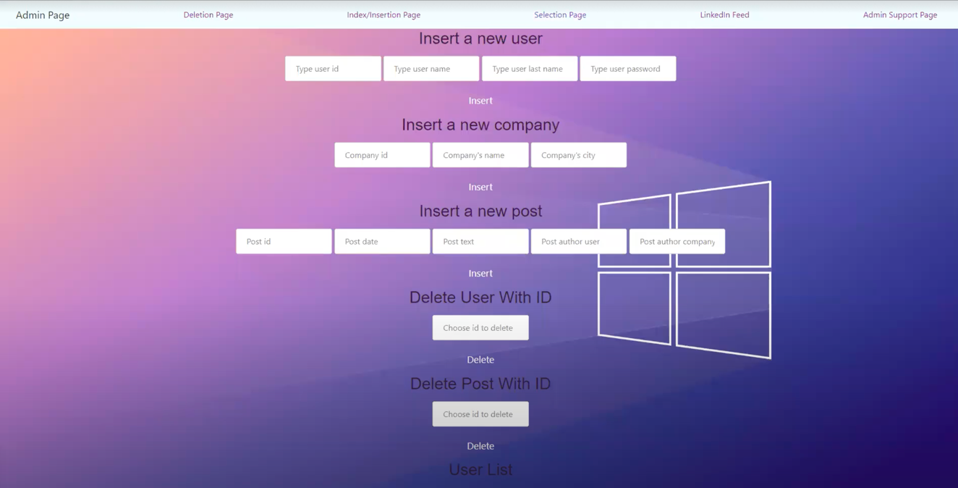

*Figure1: Interface*

**Collection**

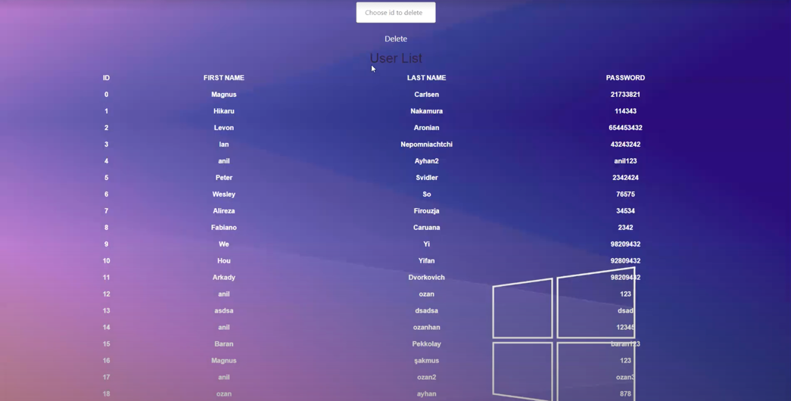

*Figure2: collection 1*

**Inserting Data**

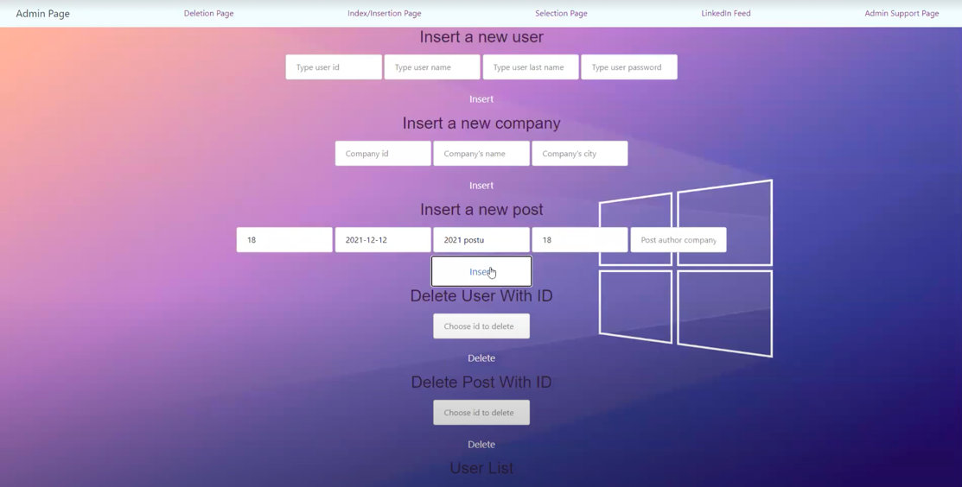

*Figure 3: Inserting the values*

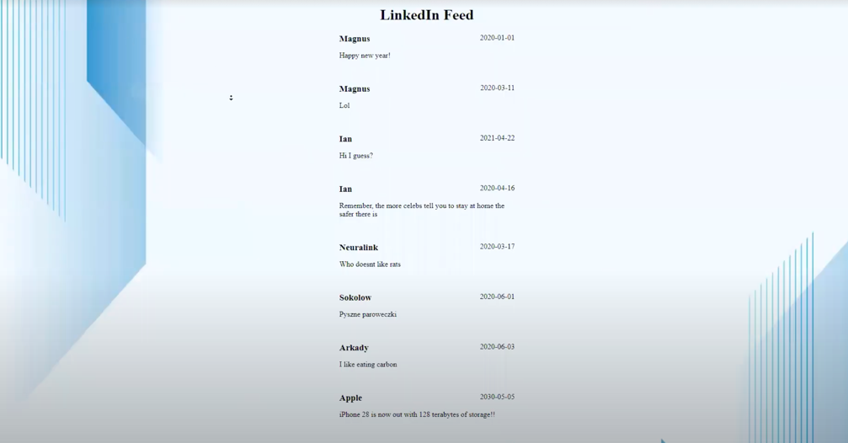

*Figure 4: Before insertion*

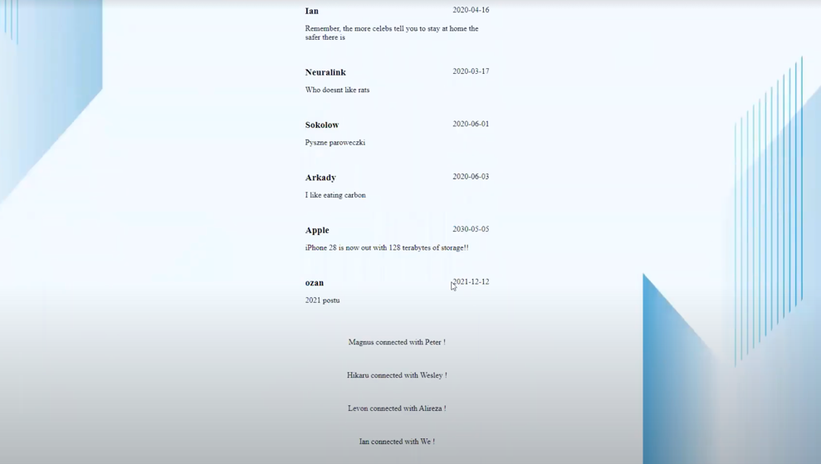

*Figure 5: After insertion*

**Deleting Data--1**



*Figure 6: Deleting data*

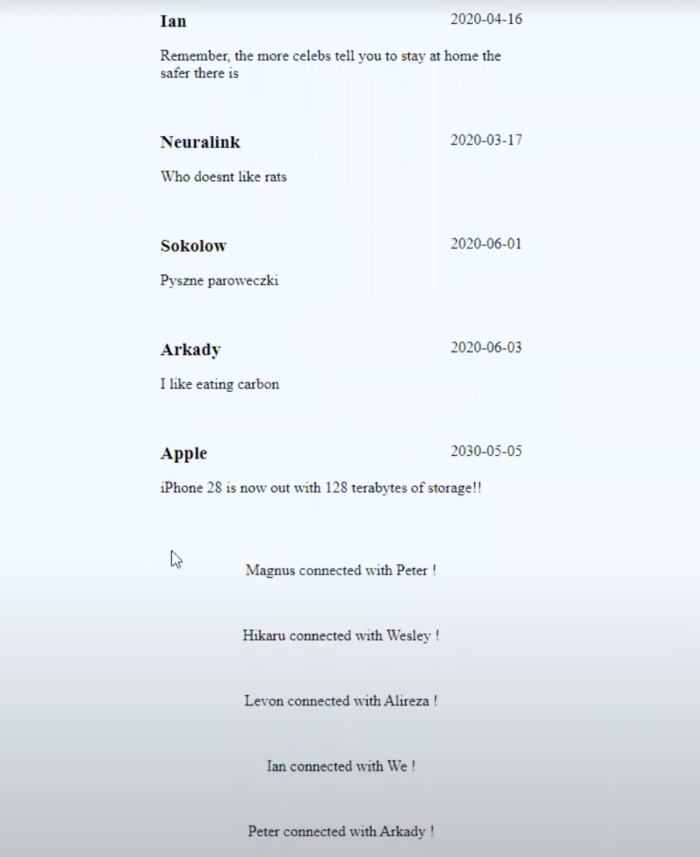

*Figure 7: After deleting post data*

**Deleting Data--2**



*Figure 8: Deleting data*

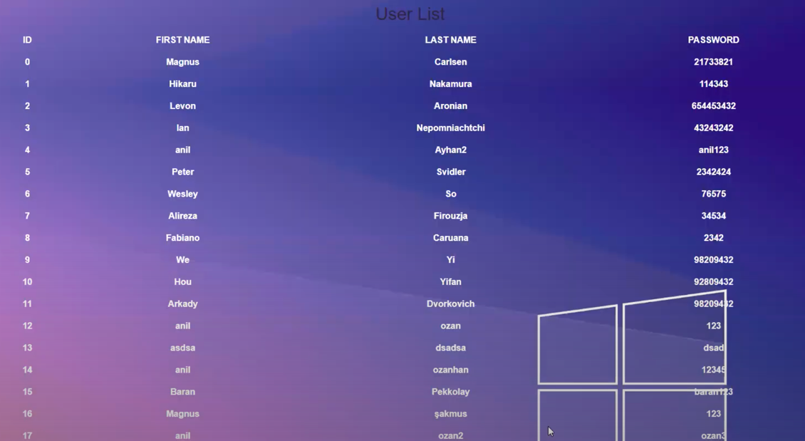

*Figure 9: After deleting user data*

**Read Some Part Of The Data While Filtering**

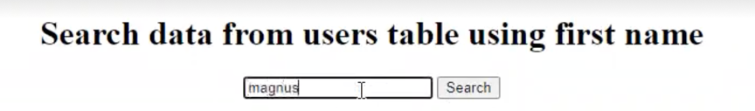

*Figure 10: Searching the data*

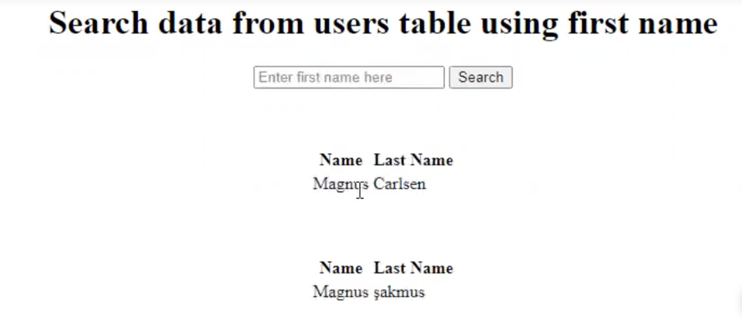

*Figure 11: Filtering the data*

**Showing That NoSQL Is Used – MongoDB**

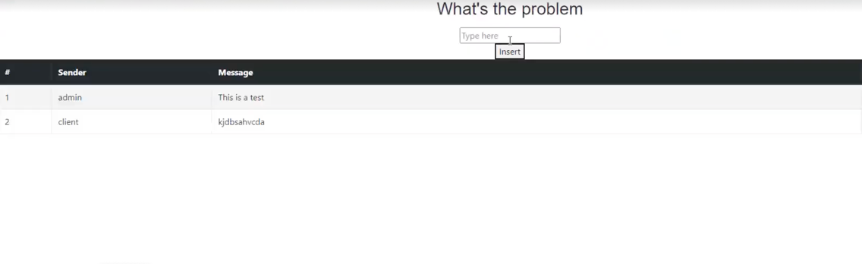

*Figure 12: Support Page*

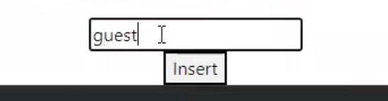

*Figure 13: Sending the messages by Guest*

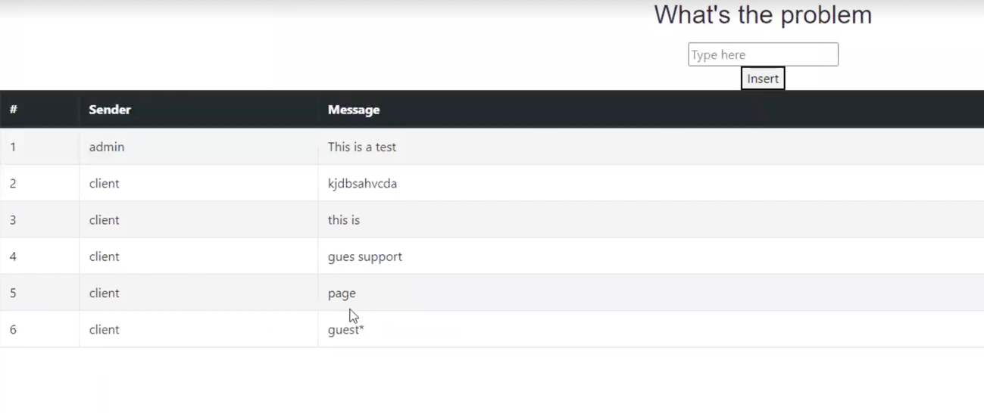

*Figure 14: The change after sending*

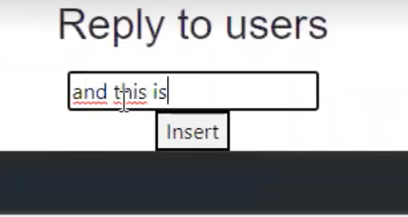

*Figure 15: Sending reply by admin*

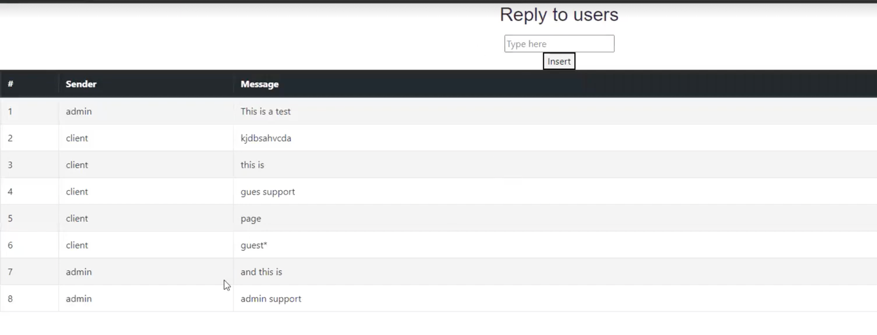

*Figure 16: After Receive & reply by admin*